Grow In Tech. Data Analysis Challenge

Embrody E-Commerce Analysis

By: Victor K. Okoye April, 2026.

A full breakdown of how 1,530 customers shop, browse, and buy; and what the business should do about it.

Tools Used
Tableau Public, Microsoft Excel.

- Summary
Embrody is attracting traffic but losing money at the checkout. Fixing the cart abandonment problem alone could recover 238 lost sales per cycle.
Out of 1,530 customer sessions, only 257 ended in a purchase. That is a 16.8% overall conversion rate. The biggest drop happens between adding to cart and completing the purchase, 38.3% of customers who add items never buy. On top of this, discounts are making things worse, not better. Customers without a discount convert higher than those with one.
This report answers seven business questions using data from the Embrody challenge dataset. It covers which channels bring the best customers, what products drive the most revenue, where customers drop off, which markets are worth investing in, what is hurting conversions, and how satisfied customers are with their experience.

- Data Source
The dataset was provided by GROW IN TECH as part of the Embrody Data Challenge. It is a structured e-commerce dataset containing records of customer sessions, product interactions, purchases, and satisfaction ratings across seven countries.
Detail | Information
Source | GROW IN TECH (challenge-provided dataset)
Total Records | 1,530 customer sessions
Countries Covered | UAE, Nigeria, France, Canada, Germany, USA, UK
Products | Floral Shirt, Luxury Jacket, Embroidered Cap, Custom Hoodie, Patch Jeans
Channels | Referral, Email, Facebook, Google Ads, Instagram
Format | Structured tabular data

Important Note
The dataset had some quality issues: missing values, inconsistent formats, and unknown entries. These were identified, documented, and handled before any analysis was done. See Section 03 for details.

- Data Acquisition, Preparation, and Cleaning
Before any analysis could begin, the dataset needed to be cleaned. Raw data is rarely perfect; this one had several problems that could have led to wrong conclusions if left unaddressed.

Problems Found and How They Were Fixed
Missing revenue values: Some records had no revenue figure. These rows were flagged using a column called ‘Revenue_Flag’ and excluded from all revenue calculations, while still being counted in session and conversion figures where revenue was not needed.
Inconsistent date formats: Order dates were written in different formats across the dataset. A cleaned date column (Date_Clean) was created to standardize this, and a Date_Flag was used to mark any rows where the date could not be reliably read.
Discount column errors: The discount field contained a mix of numbers, text, and empty entries. A new cleaned column (Discount_Clean) was created for use in the discount analysis.
Cart and purchase fields: The "Added to Cart" and "Purchased" fields had inconsistent values. Cleaned versions (Cart_Clean, Purchased_Clean) were created and used in the funnel and conversion calculations.
Unknown cart entries: 304 out of 1,530 records had an unknown status for whether the customer added an item to cart. This was documented in a Data Integrity sheet inside the Tableau dashboard so the audience could see the limitation clearly.
Rating field: Customer ratings were cleaned into a ‘Rating_Clean’ column. All values were kept, including low ratings, to give an honest picture of satisfaction.

- Data Analytics
Seven business questions guided this analysis. Each question was chosen because it connects directly to a decision the business might need to make, not just because the data was available.

# | Question | Why It Matters
1 | Are we attracting the right customers? | Traffic means little if visitors do not actually buy. Channel quality matters more than volume.
2 | What makes people buy? | Understanding which products drive revenue helps the business focus its efforts.
3 | Why do customers drop off after browsing? | If people look but do not buy, the business is losing money somewhere in the journey.
4 | Which products and markets deserve more investment? | Not all markets perform equally. Knowing where to double down and where to pull back saves money.
5 | What is hurting conversions? (Discounts) | Discounts are a cost to the business. If they do not improve sales in the end, they are wasting money.
6 | What is hurting conversions? (Devices) | If customers on certain devices buy less, the shopping experience may need to be improved for those users.
7 | What are the customer ratings? | Satisfaction scores tell you if customers are happy after buying, not just whether they bought.

Approach: Each question was answered using the cleaned dataset. The approach was to start with the big picture (how many people bought), then go deeper to understand why and where things were working or breaking down. Numbers were compared, not just counted. For example, conversion rates across channels rather than raw visitor counts.
- Data Visualization
Each question was paired with a chart type that made the answer as easy to see as possible. Here is what was used for each finding and why.

- Are we attracting the right customers?
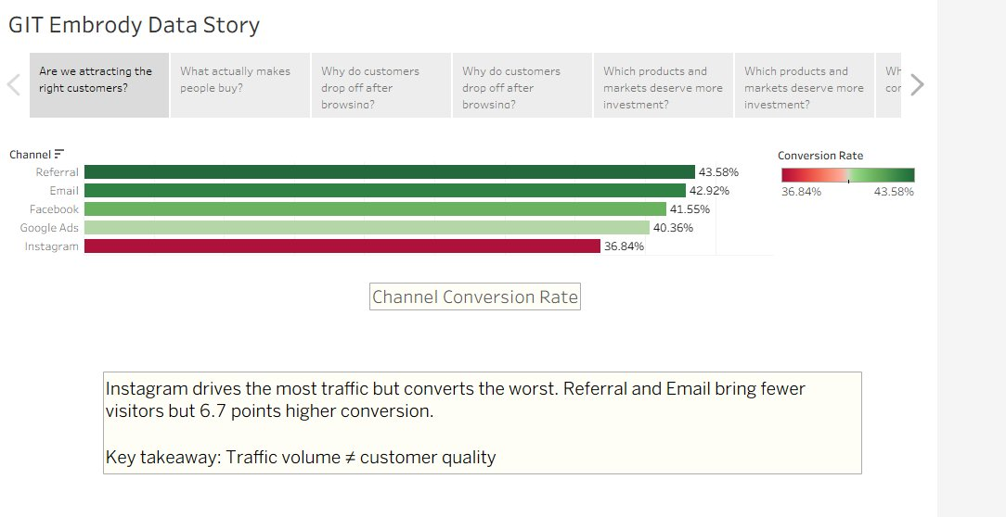
Channel Conversion Rate: Referral leads at 43.58%, Instagram trails at 36.84%

Chart used: Horizontal bar chart with color coding.
Why: Bars make it easy to compare five channels side by side. The green-to-red color scale immediately shows which channels perform well and which do not, without needing to read every number.
Instagram brings in the most visitors but converts the fewest into buyers. Referral and Email bring in fewer people but convert them at a rate 6.7 percentage points higher than Instagram.

Key takeaway: Traffic volume is not the same as customer quality. Referral and Email have shown to bring better customers.

- What actually makes people buy?
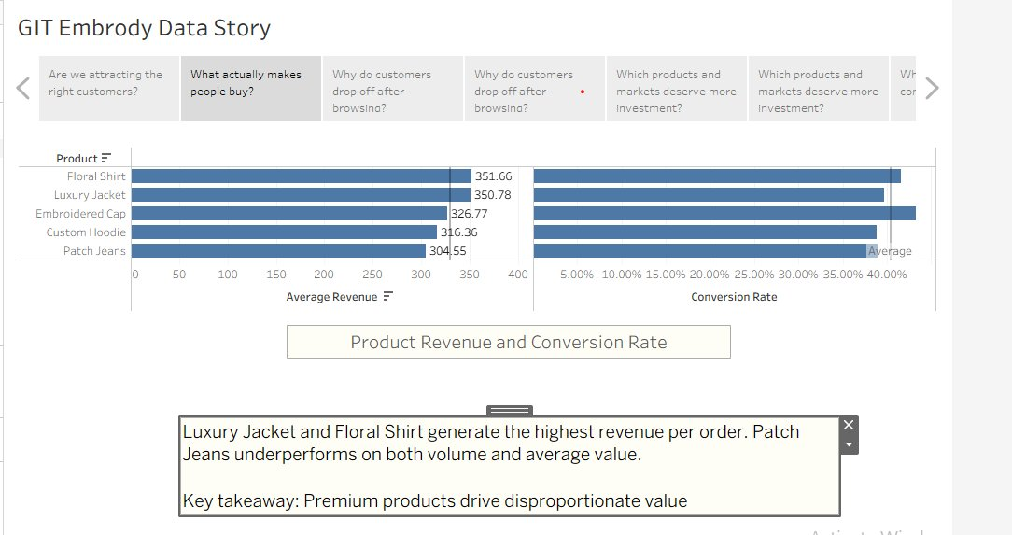
Product Revenue and Conversion Rate: Floral Shirt and Luxury Jacket lead on average revenue.

Chart used: Dual horizontal bar chart (revenue on the left, conversion rate on the right).
Why: Showing two measures side by side lets you spot products that earn well and convert well, versus products that only do one of the two.
The Luxury Jacket and Floral Shirt generate the highest average revenue per order. Patch Jeans falls below the average on both revenue and conversion rate, meaning it is neither profitable nor popular relative to other products.

Key takeaway: Premium products drive the most value. Patch Jeans needs attention, either improved promotion or a pricing review.
- Why do customers drop off after browsing?
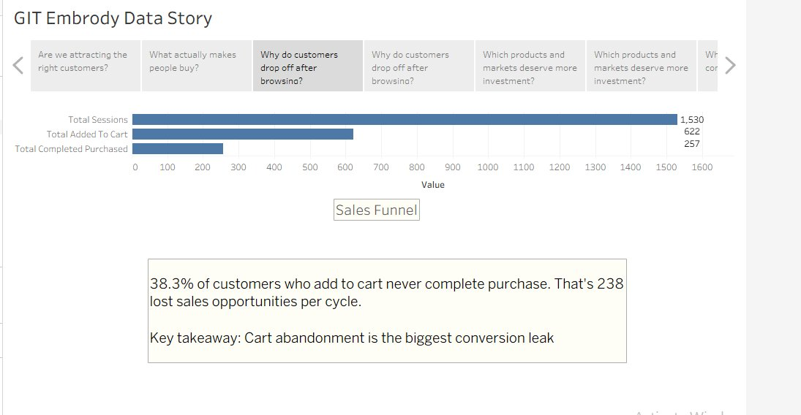Sales Funnel: 1,530 sessions, 622 added to cart, 257 completed purchases

Chart used: Horizontal funnel bar chart. Why: A funnel chart shows how many people move from one step to the next. The shrinking bars make it immediately obvious where the biggest drop-off happens.
Out of 1,530 sessions, 622 customers added something to their cart. Only 257 completed the purchase. That means 38.3% of people who showed enough interest to add an item to their cart still did not buy, representing 365 lost sales opportunities per cycle.

Key takeaway: Cart abandonment is the biggest conversion leak in this business. Fixing this one step would have the greatest impact on revenue.

- Which markets deserve more investment?
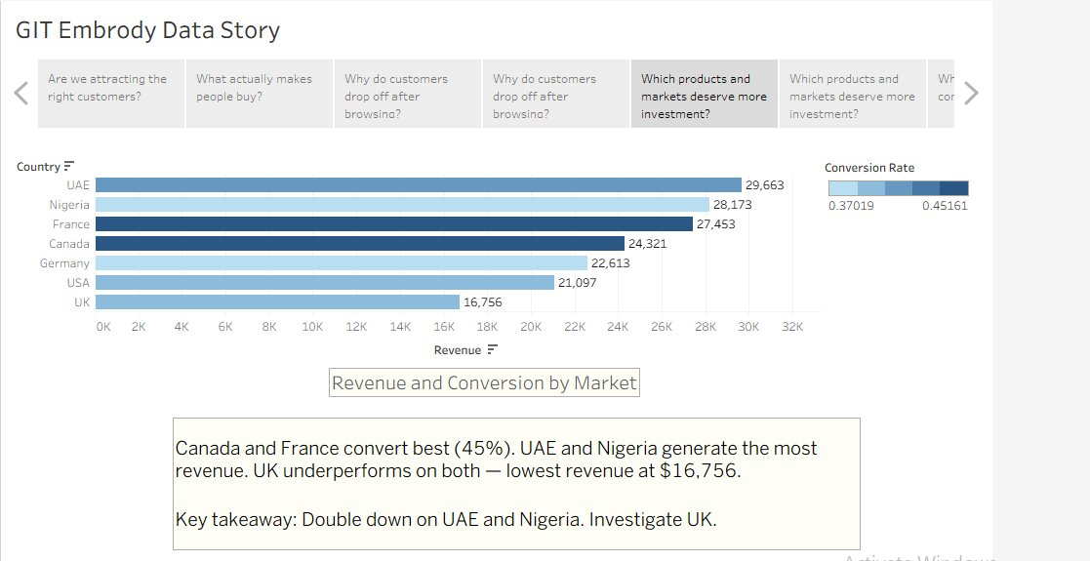
Revenue by Market: UAE leads with $29,663. UK is lowest at $16,756
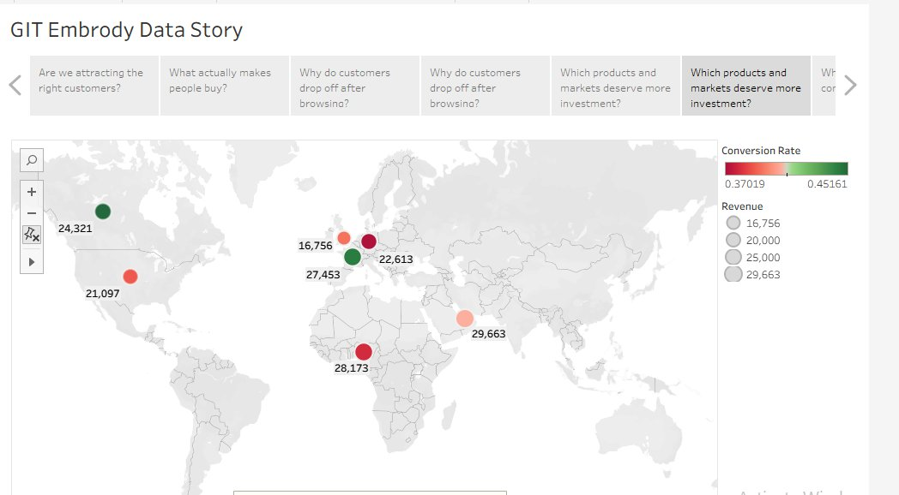Global Market Map: bubble size shows revenue, colour shows conversion rate

Charts used: Horizontal bar chart (for ranking) plus a world map with bubbles (for geographic context).
Why: The bar chart gives exact numbers for direct comparison. The map adds geographic context, showing briefly that the top-performing markets are spread across the Middle East, Africa, and Europe. Two views of the same data make the story easier to understand for different types of readers.
UAE generates the most revenue at $29,663. Nigeria follows at $28,173. Canada and France convert the best at 45%. The UK brings in the lowest revenue at $16,756 and has below-average conversion, making it the weakest market in the dataset.

Key takeaway: Double down on UAE and Nigeria for revenue. Investigate why the UK is underperforming before committing more budget there.

- Are discounts helping or hurting?
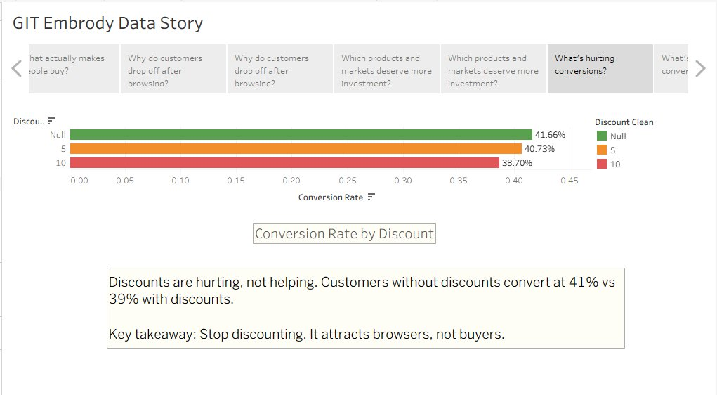Conversion Rate by Discount: no discount: 41.66%, 5% off: 40.73%, 10% off: 38.70%

Chart used: Horizontal bar chart with color coding (green = best, red = worst).
Why: When comparing three clear groups, a bar chart makes the ranking instant to read. The color scale reinforces which group performs best without needing the viewer to analyze numbers first.
Customers with no discount convert at 41.66%. Customers with a 5% discount convert at 40.73%. Customers with a 10% discount convert at only 38.70%. The more discounts, the lower the conversion rate.

Key takeaway: Discounts attract browsers, and not buyers. They are costing the business money without increasing sales. A smarter discount strategy: targeted at specific moments like cart abandonment might work better.

- Does the type of device customers use make a difference?
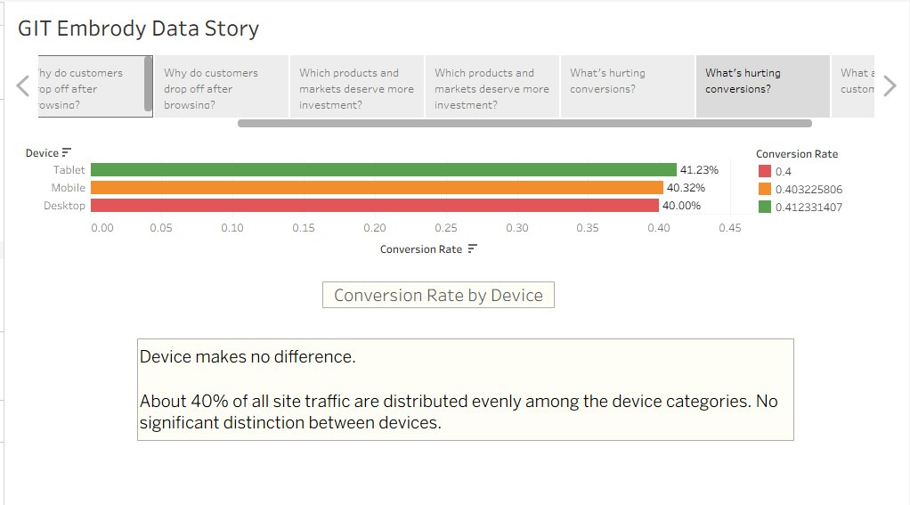Conversion Rate by Device — Tablet: 41.23%, Mobile: 40.32%, Desktop: 40.00%

Chart used: Horizontal bar chart with color coding.
Why: Same logic as the channel and discount charts. Bars make comparison across categories quick and clear. The color scale highlights small differences between groups.
Conversion rates are nearly identical across Tablet (41.23%), Mobile (40.32%), and Desktop (40.00%). The device a customer uses has almost no impact on whether they buy.

Key takeaway: Device type is not a problem for this business. Website works well for all users.

- What are customers saying through their ratings?
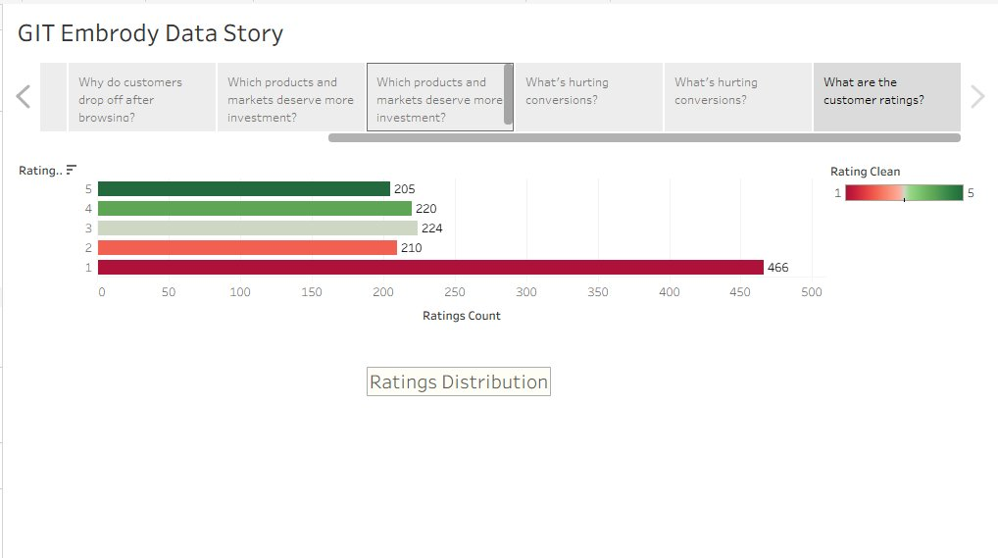Ratings Distribution: Rating 1 (lowest) has the most entries at 466

Chart used: Horizontal bar chart with color gradient (red = low rating, green = high).
Why: Showing all five rating categories as bars makes it easy to see the full distribution at once. The color coding makes the pattern: that 1-star ratings dominate, immediately visible before reading a single number.

The most common rating is 1 out of 5, with 466 customers giving the lowest possible score. Ratings 2 through 5 are relatively evenly distributed between 205 and 224 each. This is a serious warning sign: the largest single group of customers are the most dissatisfied.

Key takeaway: Customer satisfaction needs urgent attention. A business with many 1-star ratings risks losing repeat customers. Understanding what is driving low ratings: product quality, delivery, or service, should be a priority.

- Data Presentation

The analysis was presented as an interactive Tableau Story, a format that guides the viewer through each finding one slide at a time, like reading chapters in a book. This was chosen because it keeps complex analysis simple and focused, letting the audience follow a clear path rather than getting lost in a dashboard with too many things happening at once.

Where It Is Published
Platform | Purpose | Link
Tableau Public | Interactive dashboard: viewers can explore the charts themselves | Published on Tableau Public profile
LinkedIn | Professional audience: project post with key findings shared publicly | Posted on Victor Okoye's LinkedIn page

Tableau Public lets technical audiences interact with the data directly. LinkedIn reaches business decision-makers and potential clients who may not use Tableau but still need to see the work. Publishing on both maximizes the reach and usefulness of the project.

- Conclusion and Recommendation.
Embrody has come a long way as in becoming a global business. The insights drawn from their data will help it to grow even more. This analysis is but the first step to solving the problems they might not even know existed in the first place.
They may want to focus on the following areas:
- Data Integrity: Messy data is expected in the real world. However, proper structure for data collection could be implemented e.g. dropdowns in selector fields, default values, etc.
- Traffic volume is not the same as customer quality. Referral and Email have shown to bring better customers. They may consider referral campaigns or email marketing.
- Cart abandonment is the biggest conversion leak in this business. Fixing this one step would have the greatest impact on revenue. Cart reminders and similar product offering may reduce cart abandonment
- Double down on UAE and Nigeria for revenue. Investigate why the UK is underperforming before committing more budget there. Focus on what works and do more of it.
- Discounts are attracting browsers, not buyers. They are costing the business money without lifting sales. A smarter discount strategy: targeted at specific moments like cart abandonment would work better.
- Customer satisfaction needs urgent attention. Embrody needs to find out why their customers are not satisfied. Perhaps a timely survey after purchase can get insights on customer product experience.

Special thanks to Grow in Tech (GIT) for this wonderful opportunity to take my skills and apply them to a real-world data problem. It has been as challenging as it has been educational.
I will continue to learn, improve from feedback and grow as a data professional.

